### π-HuB Project: Seed Programme 2024 – Call for Proposals

In our pursuit to unlock the complexities of the human proteome and fully harness its potential for groundbreaking biomedical advancements, we are proud to introduce the **π-HuB Project (Proteomic Navigator of the Human Body)**. This ambitious scientific initiative aims to develop an advanced computational engine—**the π-HuB Navigator**—designed to integrate and analyze multi-modal proteomic datasets. By doing so, we seek to deepen our understanding of human biology, facilitate more accurate disease risk assessments and diagnoses, uncover novel drug targets, optimize therapeutic strategies, and ultimately drive the future of intelligent healthcare solutions.This transformative mission will and only be realized through a collaborative international effort, engaging multidisciplinary research teams from academia, industry, and government sectors across the globe.

Given the extensive scope of the project—encompassing the analysis of vast numbers of human samples, including sorted single cells from various organs and clinical biospecimens—there is an urgent need for cutting-edge, ultra-high throughput facilities dedicated to data generation, collection, and processing. To address this, we are launching the **Seed Programme** as a pilot initiative under the π-HuB Project.

Leveraging the robust infrastructure of the π-HuB Project's international headquarters in Guangzhou, China, the Seed Programme will tap into the powerful resources of our state-of-the-art Omics data factory. This facility is home to a professional proteomics and metabolomics team comprising over 20 scientists, equipped with 17 advanced LC-MS/MS instruments. Since its establishment in 2021, the Seed Programme has supported nearly 30 research initiatives, analyzed over 40,000 cohort samples, and provided funding totaling more than 60 million RMB.

These resources have already proven instrumental in developing precise and targeted strategies to tackle major diseases such as liver, ovarian, and breast cancer, underscoring the immense value of large-scale scientific infrastructure. Through this initiative, we aim to continue fostering groundbreaking research and accelerating discoveries that will pave the way for transformative healthcare solutions.

## Program Settings and Funding Areas for 2024

To accelerate the π-HuB Project and maximize the data output and analytical capabilities of the leading proteomics platform, we are going to expand the funding scope for Seed Programme in 2024. This expansion is rooted in our dedication to enhancing support, with a focus on the following three primary research areas:

1. **Principles of cell type organization**
2. **Proteomics-driven lifestyle guidelines**
3. **Generalization of proteomics-driven precision medicine**

We invite researchers and institutions to engage with us in this groundbreaking endeavor, as we collectively strive to advance our understanding of the human proteome and its implications for health and disease.

### Funding Plan for 2024

In 2024, financial support for the Seed Program will be available for **one proposal up to a maximum of 1,000,000 RMB (Covering about 500-1000 samples for whole proteome profiling with DIA or 700-1000 hours for MS measurement)**. These funds will primarily cover services such as research equipment, instrumentation, software, and computational support. However, they do not extend to costs related to salaries, scholarships, or assay materials.

Fund allocation will be determined by the quality, innovation, and relevance of the proposed research. Notably, exceptional and high-impact initiatives may be subject to separate funding negotiations. Applicants are encouraged to align their funding requests with the specific needs of their projects, which are expected to span 2 to 3 years.

**We anticipate supporting between 10 and 20 programs in 2024**, with the exact number of awards contingent upon the applicant pool. Successful programs will gain access to advanced resources, including mass spectrometry, computational support, and data storage facilities provided by the π-HuB infrastructure. Additionally, they will benefit from comprehensive assistance in proteomics data generation, analysis, and knowledge extraction.

### Application Requirements and Notices

**Eligibility**: Applicants must hold senior academic positions and have a background in basic or applied research, or related fields.

**Submission Process**: Applications should be submitted electronically to pi-hub@ncpsb.org.cn, with the subject line **'π-HuB Project–Seed Program Application 2024'**, by **January 30, 2025**.

**Project Monitoring**: To ensure effective progress and foster cohesive research, the Steering Committee and Working Group will organize annual meetings and regular workshops. These events will facilitate communication, collaboration, and coordination among participants. Principal Investigators (PIs) are expected to attend these workshops and meetings, allocate funds for associated costs, and coordinate participation with their international research partners.

### Additional Instructions

**Sample Registration**: For selected programs, it is mandatory to register all sample submissions. If the project involves human genetic resources, appropriate declarations and registrations must be completed in accordance with local regulations.

**Program Collaboration**: Applicants are strongly encouraged to collaborate with experts in proteomics, bioinformatics, and foundational research from the π-HuB Project’s infrastructure. Such partnerships should focus on comprehensive omics data analysis, functional validation, and other related studies. The sharing of research outcomes and intellectual property will be governed by contributions or formal collaboration agreements.

**Result Attribution**: When publishing relevant findings, applicants are required to acknowledge the π-HuB Project, π-HuB Project infrastructure, and other relevant entities as specified.

**V. Annexes**

**π-HuB infrastructure**

This platform has established a world-class innovative team, centered around high-caliber interdisciplinary talents in proteomics, metabolomics, informatics, and other related fields. This team has developed the world's first fully automated proteomics analysis platform, as well as platforms for spatial proteomics, single-cell proteomics, metabolomics, cellular biology, molecular biology, and bioinformatics. These advancements provide robust technical support for the organization and implementation of Seed Programme and extensive collaborations.

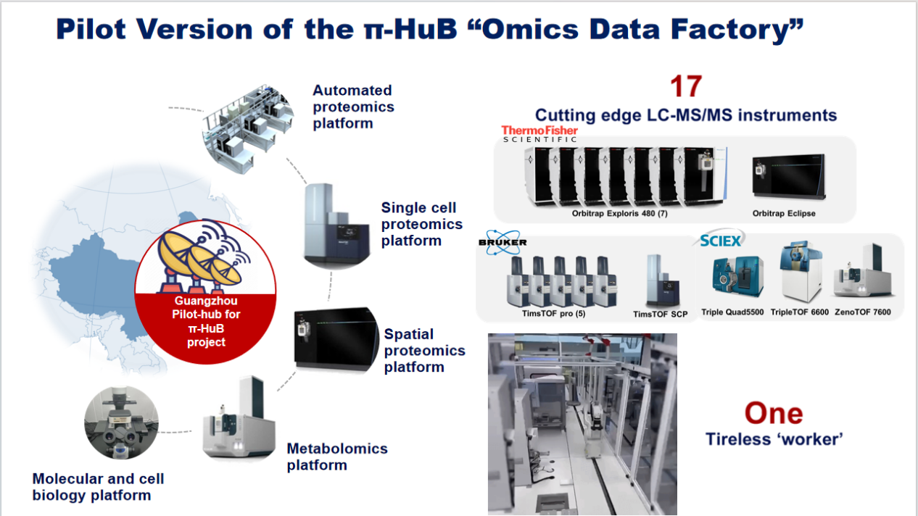

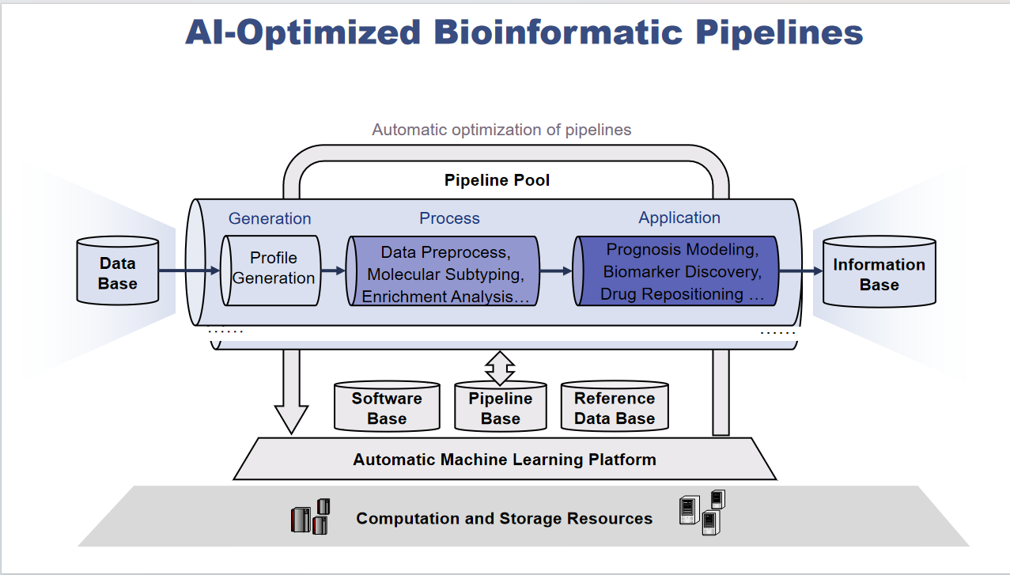

|  |  |  |
| --- | --- | --- |
| **Types of Services** | **Instruments** | **Service Requirements** |
| Whole proteome profiling | Exploris 480 | Label-free Quantification with DDA |
| timsTOF Pro |
| Eclipse |
| Exploris 480 | TMT Quantification |
| Eclipse |
| Exploris 480 | Label-free Quantification with DIA |
| timsTOF Pro |
| Eclipse |
| DDA library |
| PTM Analysis | Exploris 480 | Label-free phosphoproteomic analysis |
| timsTOF Pro |
| Eclipse |
| Exploris 480 | TMT-based phosphoproteomic analysis |
| Eclipse |
| Exploris 480 | Label-free ubiquitinome profiling |
| timsTOF Pro |
| Eclipse |
| Exploris 480 | N/O- Glycoproteome profiling |
| timsTOF Pro |
| Eclipse |
| Exploris 480 | Label-free acetylome profiling |
| Eclipse |
| Exploris 480 | Succinylation |
| Exploris 480 | Nitrosylation,Thiolation |
| Exploris 480 | Palmitoylation |
| Exploris 480 | Disulfide Bond Assessment |
| Specialized Proteome Analysis | timsTOF ProSCP | Single cell proteomics |
| Exploris 480 | Metaproteome |
| timsTOF Pro |
| Exploris 480 | FFPE proteomics |
| timsTOF Pro |
| Exploris 480 | Exosome |
| timsTOF Pro |
| Metabolomics Analysis | Q-TOF 6600 | Untargeted Metabolomics Analysis |
| Zeno-TOF 7600 |
| Q-TOF 6600 | Untargeted Lipidomics Analysis |
| Zeno-TOF 7600 |
| Q-TOF 6600 | Integrated Metabolomics and Lipidomics Analysis |
| Zeno-TOF 7600 |
| Triple Quad 6500+ | Targeted Analysis of 35 Bile Acids |
| Targeted Analysis of Sterols |